YES! Count me in as a
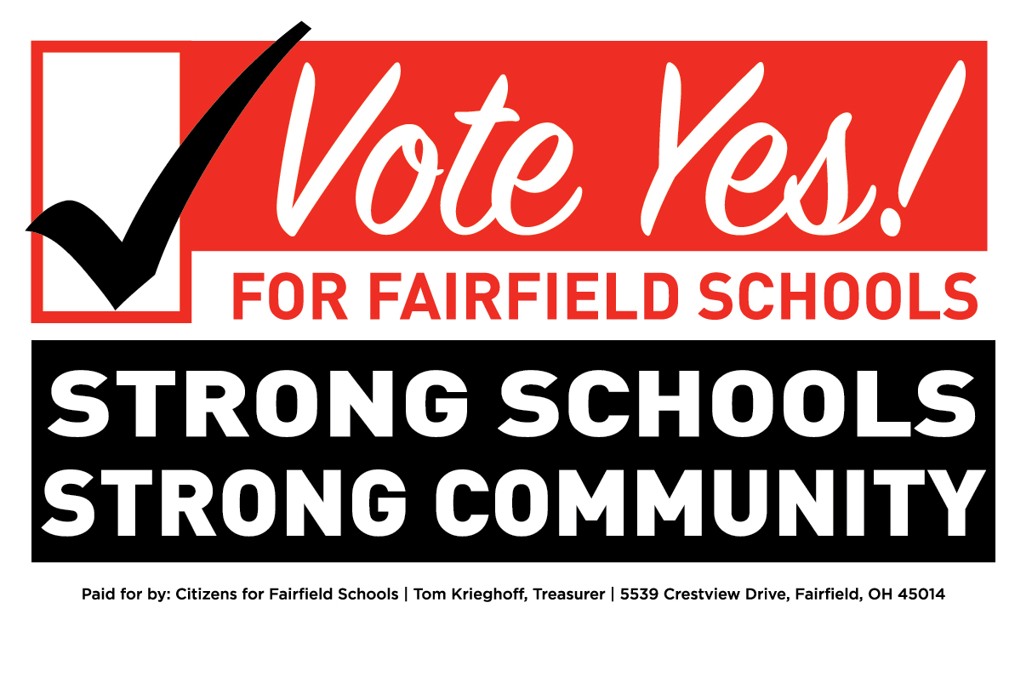
FAIRFIELD CAMPAIGN VOLUNTEER
Successful school levy campaigns depend on volunteers who care!
Please help us ensure victory on November 8!
Visit www.fairfieldcityschoolslevy.com for more information.

______________________________________________ ___________________________________________________
NAME ADDRESS

______________________________________________ ___________________________________________________
EMAIL HOME PHONE

______________________________________________ ___________________________________________________
CELL PHONE WORK PHONE

I am a(n)
□ Parent with child(ren) at Fairfield City Schools □ Employee of Fairfield Schools
□ Parent with child(ren) younger than age 5 □ FHS Alum
□ Parent with child(ren) attending private school □ Resident who does not have children at Fairfield Schools
□ Parent of an FHS Graduate □ Business Owner

I would like to (feel free to check more than one)
□ Be a member of the Fairfield Neighborhood Team and distribute literature in my neighborhood
(a very important task in which you will have 2-3 days to distribute literature to homes in your neighborhood)
□ Make phone calls (an important part of the campaign; likely part of a two-hour evening central phone bank to reach out to supporters and voters)
□ Place a yard sign on my property
□ Write postcards (may be done at home using a furnished script)
□ Work at the polls on Election Day, Tuesday, November 8th (a two-hour high visibility commitment)
□ Help with campaign events
□ Other – Here is how I think I can help the campaign: _____________________________________________________
□ YES, I authorize the use of my/our name in an ad that will appear the final weeks of the campaign.
My (our) name as it should appear in the advertisement (please print) ______________________________________
□ YES, send me_____Vote By Mail application(s) to ensure my/our vote is counted!

□ YES, I will make a financial contribution to Citizens for Fairfield Schools
(No district money can be used for the campaign.)
My check (made payable to Citizens for Fairfield Schools) in enclosed for:
□$20 □$25 □$50 □$100 □$250 □Other_______________
Contributions can also be made (securely via PayPal) on our website: www.fairfieldcityschoolslevy.com.
Forms and donations can be mailed to:
STRONG SCHOOLS
STRONG COMMUNITY

Jennifer Gilbert, Volunteer Coordinator
1435 Bruton Parish Way
Fairfield, OH 45014

